## ***Prediction of Forest Fire Susceptibility Using UAVs and Fire Weather Index Algorithm in Montana***

### **Abstract**

Forest fires have become an increasing issue that is detrimental to surrounding biodiversity, ecosystems, and human health. Because of this increasing and significant threat to biological species, fire prevention strategies are essential to mitigate these occurrences. This study was performed in locations around Missoula and Great Falls, Montana. A variety of weather-related variables along with the Canadian Forest Fire Danger Rating System (CFFDRS) were assessed to determine susceptibility to forest fires. The variables accessed included relative humidity, wind speed, precipitation, temperature, and surface soil moisture content. This study utilized UAV drone findings from GoPro and NDVI imaging. This study also incorporated ground data collection, including soil coring, assessment of location-specific variables, and plant identification. Values derived from this data collection were plugged into various equations within the Fire Weather Index (FWI) and Fire Based Predictions (FBP) algorithm. The assessments of these Montana-specific sites resulted in a wide variety of FWI values. These values ranged from very low to very high on the fire danger rating scale, ranging from the lowest value of 1 to the highest calculated value of 39. The average FWI value recorded across all sites was 12, which is classified as moderate. Therefore, it was determined that the likelihood of forest fires occurring in these specific areas is highly probable. It was also determined that the location-specific variables assessed played a major role in the final determination of fire susceptibility.

### **Introduction**

Forests are necessary because of the extensive array of life they support and house. Forests provide habitats for animals and support plant species. Plants like grasses, shrubs, and flowers prevent erosion, cycle water, and convert carbon dioxide to oxygen. The plants and animals support each other. The relationship between biodiversity and productivity in forests shows their importance. The more diverse a forest is, the more it is a productive part of an ecosystem [1]. Forests provide essential refuge for both animals and humans from urban landscapes. The possibility of severe wildfires threatens these shelters. Wildfires can be detrimental to the environment and surrounding ecosystems. Forest fires start when three major things are combined: fuel (wood, brush, lichen), oxygen, and ignition source (heat). Together, these are referred to as the fire triangle [2]. Removing even one of these factors will cause a fire to stop burning. More often than not, forest fires occur due to human influence [3]. WIldfires severely affect wildlife by directly killing or damaging habitats. Fires limit food sources, lower water and air quality, increase soil erosion, and impact tree regeneration. However, forest fires do have some benefits. The life cycle of some coniferous trees requires fire to open their cones. Fires also aid in the decomposition of dead plant matter [4]. Forest fires are inherently hard to study due to their dangerous nature. A wide array of factors make fires difficult to analyze. These include size, rate of change, and possible study methods [5].

Montana is a diverse state with many contrasting ecosystems and climates. There are four main categories that all Montana environmental areas fall under [6]. The Crown of the Continent is in northwest Montana (Fig. 1). The High Plains are found in northeast Montana. The Upper Missouri portion is located in central Montana. Finally, the Greater Yellowstone region is in southern Montana. In May, the climate of Montana varies depending on the area. In varying locations in Montana, the average daily temperature can change drastically. The average temperature can be 13 ℃ in Big Sky, a town in the Yellowstone region, and 22 ℃ the same day in Hardin, a location with more grasses and plains [7]. The average overnight temperatures range from 6 ℃ in Big Sky to -1 ℃ in Hardin. The precipitation levels during May can oscillate from 79 mm to 110 mm depending on the area.

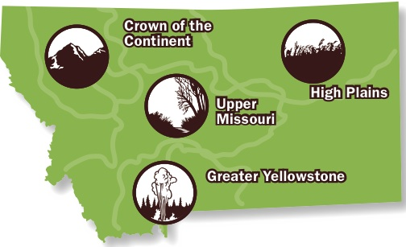

**Fig 1: The ecosystems of Montana. Image from: Reference 7**

Of the 9 million acres of Montana, about 80% of it is at moderate to high risk of wildfire [8]. As previously stated, wildfires can be good. However, these fires have continuously increased and gotten out of control. In the summer of 2000, major wildfires burned over half a million acres in Montana [8]. Wildfires in Montana have sharply increased over the past 40 years. Ten of the worst fire seasons, based on acres burned, have been in the past 16 years. These wildfires destroyed vegetation, houses, and natural resources [9]. The smoke from these wildfires is also detrimental to the public’s health. Exposure to this smoke can result in many diseases. Some of these health problems include strokes, heart attacks, heart failure, asthma, and pulmonary disease [9].

Within the western US specifically, wildfires consume more area because of the temperature rise. The average daily temperature in Yellowstone has increased by 2.3 ℉ since 1950. The hotter the weather is, the more fire consumes the ecosystem. This warming climate and dry areas can make reburning more likely and tree regeneration riskier [10]. Along with temperature continually increasing, the average forest fire season length (comparing 1970-1986 and 1987-2003) has become 78 days longer, or increased by 64% [11]. Given the escalated frequency of wildfires in the forest ecosystems of Montana, it is crucial to understand and implement preventative strategies for future forest fires. Conclusions from previous studies may be pivotal for an ecosystem’s survival. Knowledge of the variables the researchers studied and how they contribute to the susceptibility, range, and magnitude of forest fires can be valuable in aiding the prevention and integration of management strategies.

It is well-documented that forest fires detrimentally affect ecosystems, specifically those more susceptible to fire. Logically, it is critical to understand the path of forest fires more accurately. Several articles have been written on the ability to track and model forest fires. Still, fewer studies have tried to predict forest fire susceptibility, particularly in uncontrolled environments. The researchers of these minor studies focused on specific sets of variables. One study in the western United States examined the escalation of wildfire activity concerning precipitation levels [12]. Another article explored the effects forest fires have on soil properties. These properties allowed the researchers to calculate the susceptibility of the studied area [13]. A study conducted in the forests of the western United States focused on the regional and topographical variations that could contribute to the occurrence of wildfires [14].

A few studies have used algorithms to predict the behavior of fires in the western United States [15]. This piece of research used the National Wildfire Coordinating Group (NWCG) as a source. This organization analyzed several past wildfires in pine forests in Alaska, Michigan, and Minnesota [16]. The researchers utilized the Fire Weather Index (FWI) System and the Fire Behavior Prediction (FBP) System. The FWI system depends entirely on weather data like temperature, relative humidity, wind, and precipitation. This system also uses fuel moisture and the Initial Spread Index (ISI) to determine fire spread potential. FWI and FBP work as an algorithm. Data like the spread rate of fire and burned acres can be calculated and predicted. A version of the FWI and FBP systems has been developed by the Canadian Forestry Service [17]. This specific version is a part of the Canadian Forest Fire Danger Rating System (CFFDRS). This system combines the FWI, FBP, and various other factors to predict the fire intensity, temperature, and movement. The factors calculated from this system can estimate a wildfire’s path, fuel consumption, growth rate, and flame length.

Drone spectral imaging and normalized difference vegetation index (NDVI) imaging have also been used in past experiments. These studies aimed to identify tree species through aerial imaging [18]. These experiments concluded that aerial imaging and NDVI mapping proved advantageous in determining plant species. However, these articles did not include information on the vulnerability of ecosystems to wildfires. No single research study has incorporated drone mapping, NDVI imaging, and location-specific variables to address the issue of forest fire vulnerability.

As stated previously, several climate and environmental factors affect the likelihood of forest fires in a given area. The climate and conditions exacerbated previous wildfires in Montana. Low humidity and high temperatures make it more likely for wildfires to occur [11]. These high temperatures correlate with droughts. The more severe a drought is during the summer, the higher the probability of a fire. The amount of snowfall during the winter also impacts drought occurrence [12]. Less snowfall and snowpack in the mountains mean less runoff to the plains in late spring and summer. The moisture in the soil is directly related to the amount of precipitation. Drier soil indicates that a fire is more likely to occur. This drier soil may give way to less healthy or dead plants, which are essential fuels for wildfires. Smaller trees are often a target as the flames burn through them quickly. Fires burn through trees with a smaller trunk diameter and less crown area faster, thus spreading the blaze more rapidly [19]. In addition to tree size, the density of a forest also impacts how a wildfire begins and spreads. A densely populated forest has more materials for a fire to consume, so the wildfire will be grander and spread faster. The plant’s species and inherent characteristics can make it more susceptible to burning. Dry vegetation types are more likely to be a part of high-severity wildfires, or fires where large amounts of land are significantly charred [20]. Wind speed, direction, and type can also affect fire behavior [21]. When these variables are studied and combined, they can predict how likely it is for a wildfire to begin.

Research was conducted in two opposite Montana ecosystems: the great plains and montane conifer forests. Montane conifer forests are primarily made up of douglas-fir (*Pseudotsuga menziesii)*, ponderosa pine (*Pinus ponderosa)*, western larch (*Larix occidentalis)*, lodgepole pine (*Pinus contorta),* and grand fir (*Abies grandis)* trees [22]. The great plains and shrub grasslands are primarily made up of vegetation like green needlegrass (*Nassella viridula)*, prairie junegrass (*Koeleria macrantha),* western wheatgrass *(Pascopyrum smithii),* serviceberry shrubs *(Amelanchier alnifolia),* and skunkbush sumac (*Rhus trilobata*) [23, 24]. The above variables were studied via ground collection and imaging in the Montana locations. Drones, or UAVs, were used to take aerial images. The NDVI value was calculated from the aerial photos, which indicated the vegetation’s health. Using the algorithm and tables of the FWI from the CFFDRS, these variables at sites in Montana were analyzed, and their vulnerability to forest fires was determined.

Research was conducted for four days in Great Falls and Missoula, amassing 8 days of research. Two sites were analyzed per day. Specific sunlight and weather-related data had to be collected at solar noon [1]. The temperature at noon also had to be above 12 ℃ for three consecutive days before the research could begin. Snow cover must also have not been present three days before the testing date.

### **Methods**

#### **Site Descriptions**

The sites were categorized as GF for Great Falls or M for Missoula, followed by their site number for future distinction. Site parking and navigation were provided to show the legality of flying in the specified area. A parking description was presented along with coordinates.

GF1 (Fig. 2): The site was located along Route 89 S. It is slightly steeper and has dense coniferous forests as well as a lot of plant diversity. Belt Creek runs close to the observation sites. Parking for the site is located on large gravel patches on the side of the road, which is the pull-off marked as GF1. The site is located in Lewis and Clark National Forest.

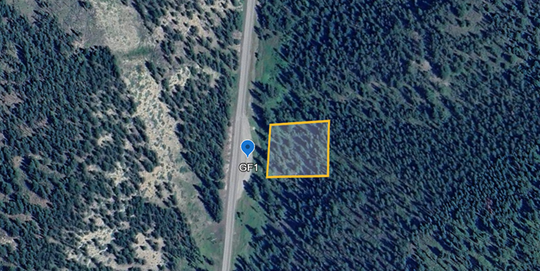

**Fig. 2**: (GF1) Site located at 47.102919, -110.831192, Monarch, Montana. (Google Maps)

GF2 (Fig. 3): The site was located along Route 89 S as well. It is quite like GF1 but south. The parking lot was a pullover in the street so the researchers walked down the road onto the trail and sampled the data. It is less steep than GF1 but the area is dense with coniferous trees and has a lot of plant diversity like GF1. This land is located in Lewis and Clark National Forest.

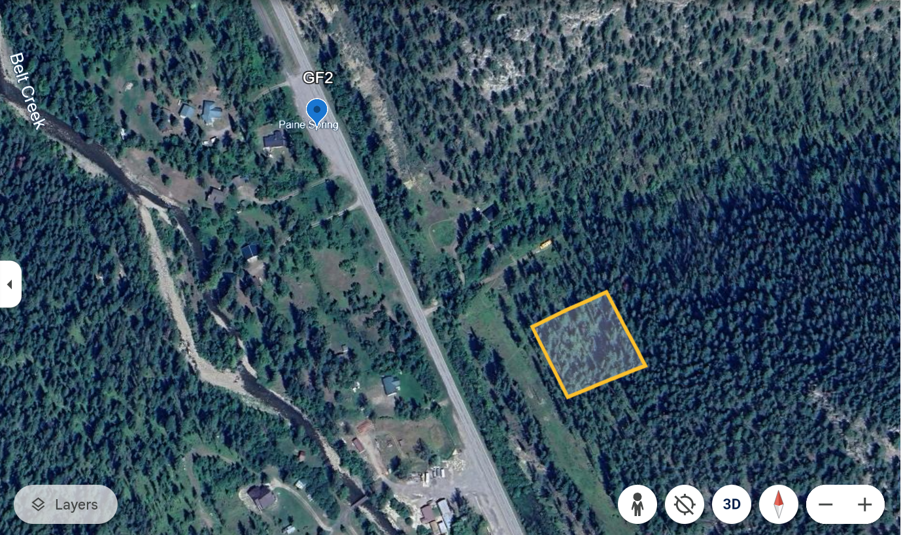

**Fig. 3**: (GF2) Site located at 47.079500, -110.822505, Monarch, Montana. (Google Maps)

M1 (Fig. 4): The site consisted of a coniferous forest with underbrush in a mountainous region close to Soudan, Montana. The area is not fully dense with trees. It is not very dry or wet. Like the other Missoula site, there is a river but it is somewhat far from the site (part of the river can be seen at the bottom left corner of Fig. 4). This site also has medium variability in elevation and the parking site is a pull-off on the left side of the road marked M1.

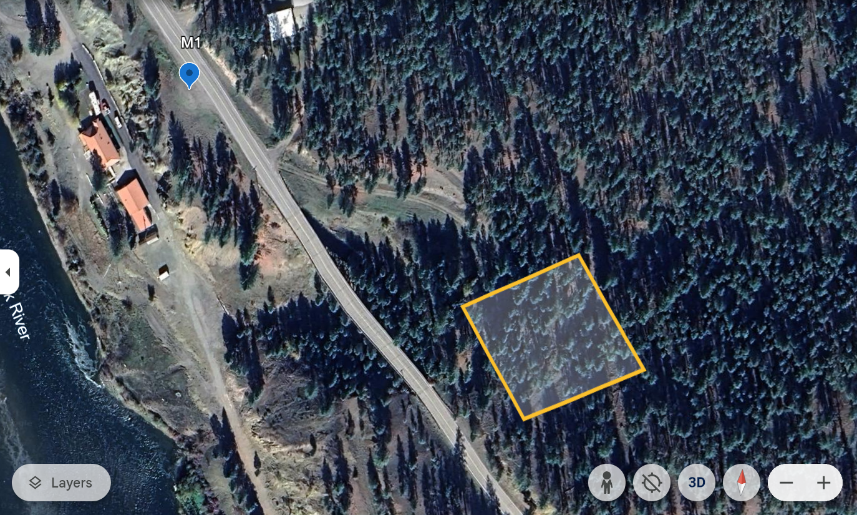

**Fig. 4:** (M1) Site located at 47.0263417, -114.3795464, in Soudan, Montana. (Google Earth)

M2 (Fig. 5): This site consists of a coniferous forest with underbrush in a mountainous region close to Soudan, Montana. It is not very dry or wet. There is a river but is comparably far from the site. This site is in a valley. The site has medium variability in elevation, and the parking site for this location is a small parking lot in front of an RV campground, in the bottom left of the figure, marked M2.

**Fig. 5**: (M2) Site located at 47.031102, -114.386340, in Soudan, Montana. (Google Earth)

#### **Testing Schedule**

**Table 1:** Part One of Montana Schedule, from departure to stop 2.

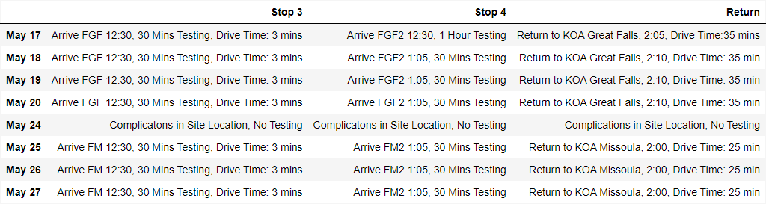

**Table 2:** Part Two of Montana Schedule, from stop 3 to returning to the KOA.

#### **Flight Paths**

The flight paths for each of the sites had equal dimensions and shutter speeds. For clear images, the minimum shutter speed was determined to be 1/90. The minimum shutter speed required was 1/8. However, 1/90 was used for maximum accuracy. With the drone being 80 meters high, each image had a length of 121 m and a width of 162 m. The area of the image was 19602 $m^{2}$. Due to the inconsistent battery life of the drone, the flight path was small, but maximized battery life. Therefore, the path was 64 m by 64 m for all sites (Fig. 4). Because the images theoretically take 30 minutes, errors resulting in less testing time or battery life due to cold weather will be accounted for. If the drone flew any faster than one m/s, the direction and quality of the pictures were affected. An image was taken every 10 seconds to ensure a clear final image. A grid was used to rectify the drone path and certify that it photographs the correct area.



**Fig. 4**: This is a depiction of the flight path used, with each vertical line evenly spaced (16m apart) and the horizontal line always at 64m long.

#### **Weather Data Collection**

For this research, the daily temperature, relative humidity (RH), wind speed, wind direction, and precipitation data were gathered. The temperature and precipitation levels were found on meteorological websites. The first of two websites was the Western Regional Climate Center (WRCC) [25]. The Desert Research Institute operates this website. This institute is one of six regional climate centers in the United States of America and is managed by the National Oceanic and Atmospheric Administration (NOAA). Upon opening the WRCC website, navigate to the “weather” tab. The subtab of interest is the “RAWS '' (Remote Automated Weather Stations) portion. Under the section titled “Station Maps and Data,” click on “Western US'', which is the area for this study. The area “Montana, Western” is then chosen. The website directs the user to a page displaying a list of RAWS in the region. Air temperature and precipitation levels (mm) were gathered from this website and utilized for the sites in Missoula, Montana. [25].

The second source was the MesoWest website [26]. This source is managed by the University of Utah Department of Atmospheric Sciences. When the website is opened, it shows a geographical map of the United States. The user then selects the region of the United States that they wish to obtain information from. The website also displays a zoomed-in version of the map with several points. The user selects a place, and the source shows the meteorological information needed. This source provides the temperature, humidity, wet bulb temperature, and precipitation [26]. This source supplied the air temperature and precipitation data for research sites near Great Falls, Montana.

An anemometer was used to determine the wind speed at each location. An example of a weather station with an anemometer is shown below (Fig. 5) [27]. A makeshift pole was created to set the anemometer on top of it. The anemometer was attached to this pole, measuring 120.5 in or 3.06 m. Because this device measures less than the standard height of 10 m, the obtained measurements were corrected (Fig 15) [27]. This table displays the values that a nonstandard mast height was multiplied by to determine the accurate wind speed for both rough and smooth terrains. For example, if the initial mast height were 3.5 m, it could be multiplied by 1.37 to calculate the wind speed for rough surfaces and 1.22 for smooth surfaces [27]. As stated, the anemometer was placed upon this makeshift pole and stabilized. This device enabled the researchers to determine each plot’s wind speed.

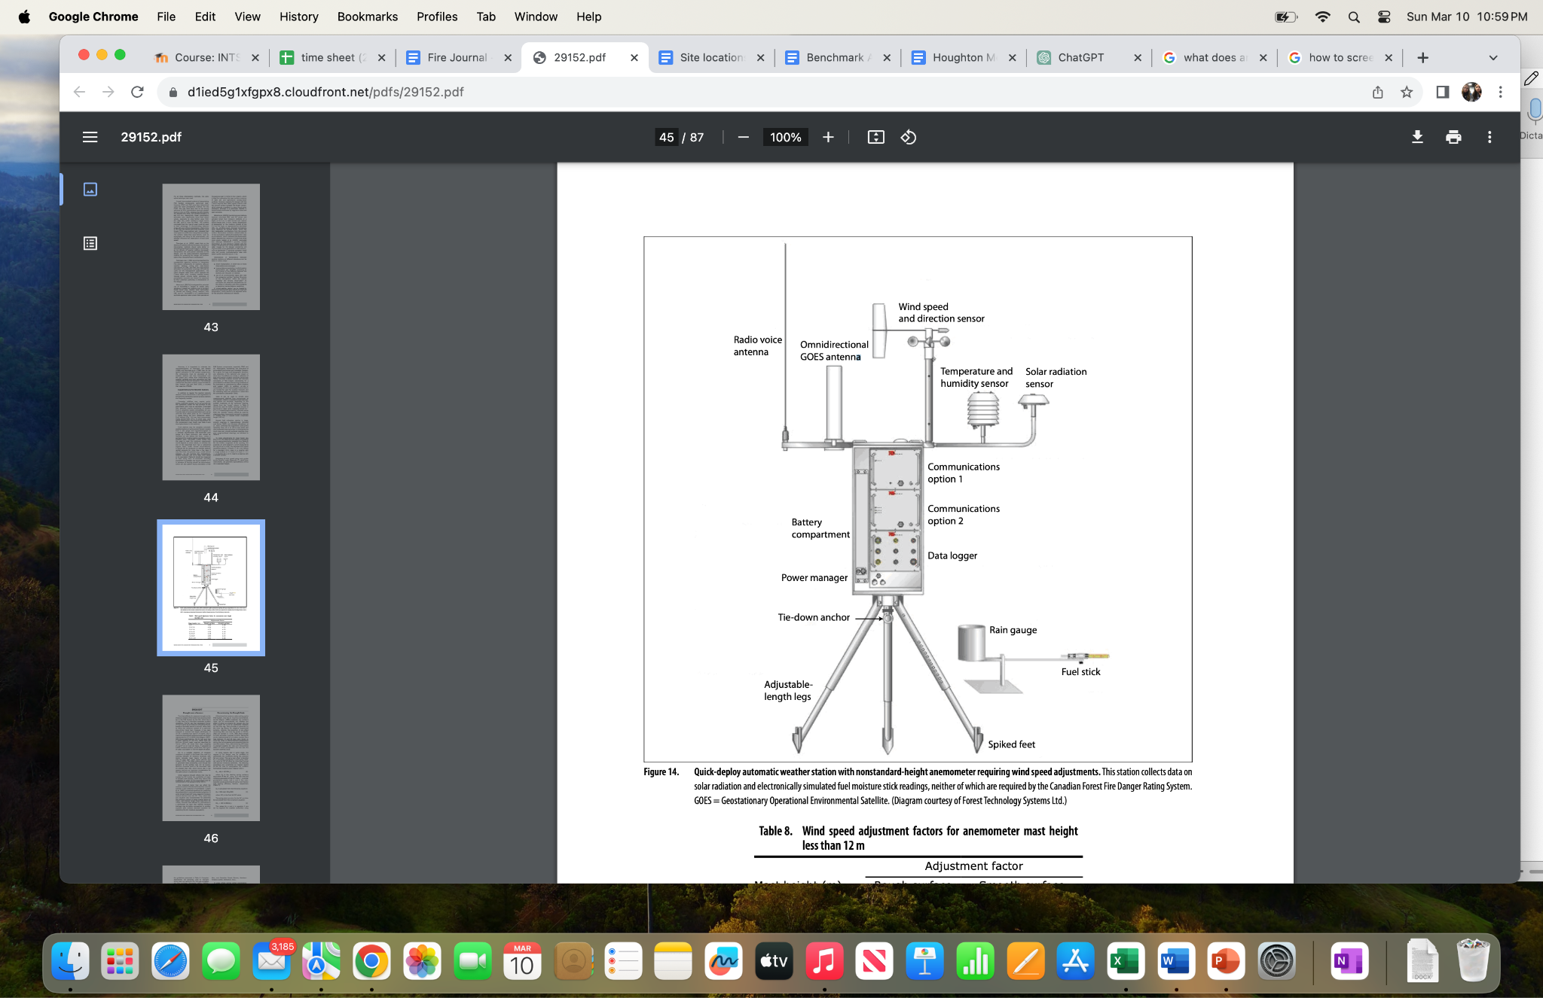

**Fig 5:** An example of an anemometer. A device like this was used to gather weather data [27].

The relative humidity (RH) was calculated by comparing the wet bulb temperature to the dry bulb temperature [27]. The Protmex HT607 temperature and humidity meter showed both temperatures. To operate this device, the power button, which is the top left button, must be pressed to turn on the device. The temperature in degrees Celsius, the percent relative humidity, and the dew point are displayed. Next, the user should press the bottom right button labeled “DP/WB.” This action will alternate the dew point value with a wet bulb temperature value, displayed in degrees Celsius. Once the RH value is determined, it can be plugged into the Fire Weather Index (FWI) algorithm alongside the other variables obtained and calculated.

#### **Surface Soil Moisture (SSM) Measuring**

One of the variables assessed and analyzed for this research was the soil moisture levels of each plot. Soil moisture plays a crucial role in a variety of environmental processes. Several techniques have been used to adequately and accurately measure the soil moisture content of soil samples. Techniques that have been employed in previous studies include direct techniques, neutron scattering, gamma-ray attenuation, domain reflectometry (TDR) sensors, capacitance sensors and frequency domain reflectometry (FDR), resistive sensors, tensiometers, hygrometric techniques, ground-penetrating radar (GPR), cosmic ray neutron sensing (CRNS), remote sensing techniques, and machine learning techniques [28].

For this research, a direct technique was utilized. The researchers used a steel soil corer to retrieve soil samples from desired plots. Each plot was divided into three transects, and a systematic sampling method was utilized. Small samples from each transect were obtained and then combined. These obtained samples were then placed in airtight ziploc bags. These bags were taken to an area to be weighed. The soil samples were put in a container, placed on a scale, and weighed to the nearest 0.5 g. The initial mass of the samples did not need to be a specific mass or remain constant throughout the study. A kitchen scale that measured to the nearest 0.5 g was utilized. The samples were then dried using small pots placed on a 20-inch griddle. When the samples were dry, they were weighed once more. To determine the surface soil moisture content, the final recorded mass of the sample was subtracted from the initial recorded mass. This value was then divided by the final mass recorded. [28]. These calculations assisted in ultimately determining the fire susceptibility of specific regions.

#### **Fire Weather Index (FWI)**

This weather data was incorporated into the Fire Weather Index (FWI) and the Fire Behavior Prediction (FBP) system from the Canadian Forest Fire Weather Index System. The FWI consists of several weather observations. It considers the temperature, relative humidity (RH), wind speed and direction, and precipitation [29]. These pieces of weather information are part of five components: the Fine Fuel Moisture Code (FFMC), Duff Moisture Code (DMC), Drought Code (DC), Initial Spread Index (ISI), and Buildup Index (BUI). These five indices are the FWI (Fig. 6). The FFMC, DMC, and DC are used to calculate the ISI and BUI, which determines the FWI value.

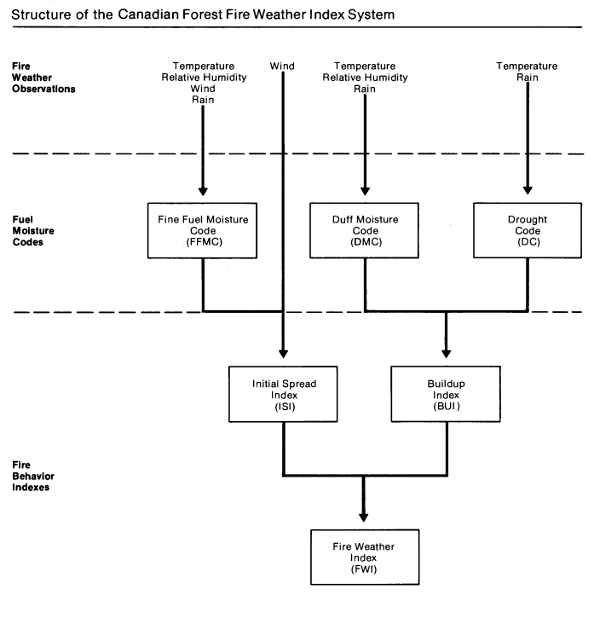

**Fig. 6**: The flowchart of indices that make up the Fire Weather Index [29].

The FFMC measures the soil moisture content regarding the last period of rainfall [29]. The starting value of 85 should be used to calculate today’s FFMC. Today’s FFMC is based on yesterday’s FFMC (85), relative humidity (RH), and wind (km/h) (Fig. 7). The tables for today’s FFMC vary based on the temperature at the time of collection, so separate tables may need to be used. RH can be calculated by comparing the wet bulb temperature to the dry bulb temperature (Fig. 8). The Protmex HT607 device calculates the dry bulb and wet bulb temperature together. This research will utilize a weather station like the Ambient Weather WS-2902 Home Weather Station. This weather station collects wind speed, wind direction, light intensity, and 24-hour precipitation, among other things. This device will be mounted on a metal pole with a height of 3.06 m. The ideal height for gathering wind speed data is 20 m, but that will not be possible for this study. Due to the lower height, the collected wind speed will be multiplied by an adjustment factor according to the terrain type (Fig. 9). If the terrain is uneven, the collected wind speed is multiplied by a factor of 1.37. If the terrain is even, the factor is 1.22.



**Fig. 7:** Today’s FFMC is based on a temperature from 15-20 ℃, RH, and wind speed (km/h) [29].

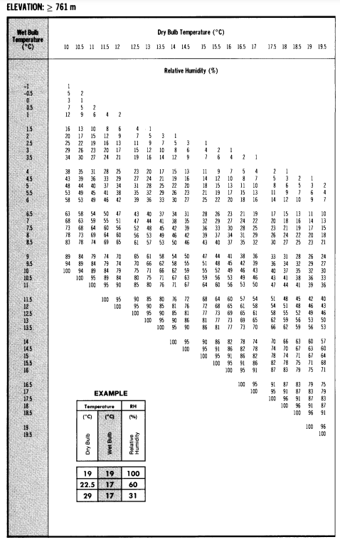

**Fig. 8:** Percent RH based on wet bulb and dry bulb temperature for an elevation of greater than 761 m [29].

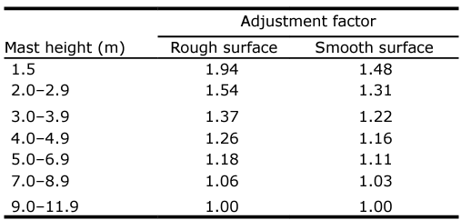

**Fig. 9:** Adjustment factors based on anemometer height and terrain type [29].

The FFMC Rain Code depends on the amount of precipitation in the last 24 hours and yesterday’s FFMC (Fig. 10). If the conditions of no snow and warmer temperatures are unmet, there is a manual way to calculate yesterday’s FFMC. The research will continue with these assumed values. After three days of continuous data collection, the system will right itself. These tables are based on an elevation of 761 m or more above sea level. An additional table can be found in the cited reference if precipitation exceeds 4.4 mm.

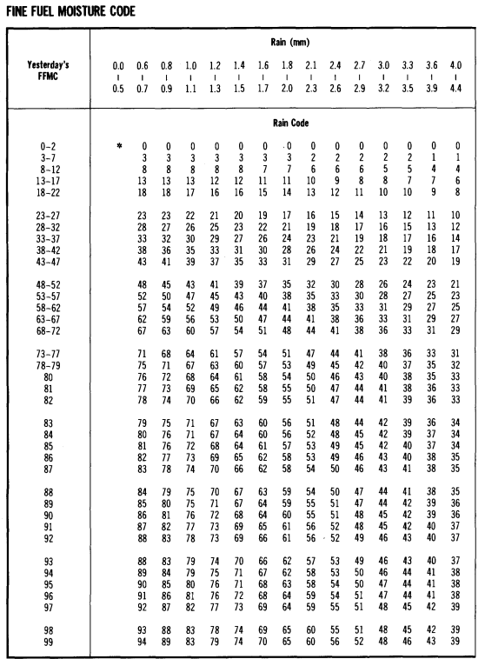

**Fig. 10:** Today’s FFMC Rain Code based on yesterday’s FFMC and 24-hour precipitation [29].

The drying factor for the DMC is calculated regarding the temperature, RH, and month (Fig. 11) [28, 29]. Today’s DMC Rain Code is computed by comparing the amount of rain in the past 24 hours to yesterday's DMC (Fig. 12). The starting value for the DMC is 6. The DMC is produced by adding the drying factor to the DMC Rain Code. The DC depends on temperature and month (Fig. 13). It generates a separate drying factor. The starting value for this index is 15. The DC Rain Code is determined by comparing the precipitation to yesterday’s DC (Fig. 14). The drying factor is added to the DC Rain Code to produce today’s DC. An asterisk (*) in the figures indicates that the Rain Code equals yesterday’s value.



**Fig. 11:** Drying Factor for the DMC calculated via temperature, RH, and month [29].

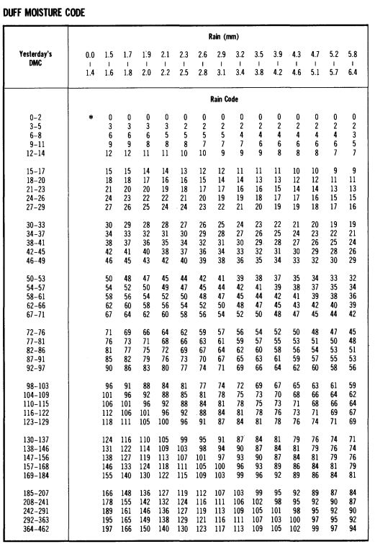

**Fig. 12:** DMC Rain Code determined by yesterday’s DMC and precipitation [29].



**Fig. 13:** The Drying Factor of the DC-based on temperature and month [29].

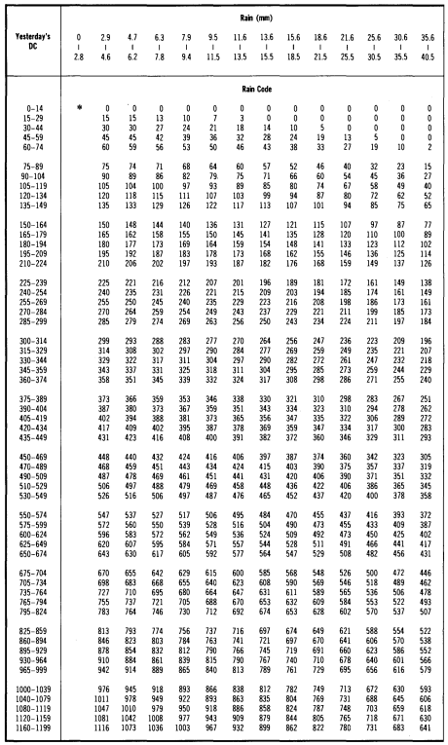

**Fig. 14:** The DC Rain Code calculated via yesterday’s DC and precipitation [29].

Today’s calculated FFMC, DMC, and DC are necessary to calculate the ISI and BUI. The ISI is determined by today’s FFMC value and wind speed (Fig 15). BUI is a combination of the calculated DMC and DC values (Fig. 16). It measures the potential heat release of fuels [30]. Once the BUI and ISI values have been set, they are plugged into a table to find the FWI value (Fig 17). The FWI measures fire intensity potential and the likelihood of a severe wildfire. The calculated FWI value can show the probability of a wildfire through fire danger classes (Fig. 18) [31]. This table is based on the European Forest Fire Information System (EFFIS) but is altered to fit the Canadian system. An FWI value of less than 5.2 means the danger is very low. However, a value greater than 50 indicates the area is in extreme fire danger. The provided tables for these indices do not include all potential values, so additional tables may need to be used. All the collected values will be compiled in a worksheet or a simple chart (Fig. 19). The data is kept in one place to be easily accessible and understandable. This chart will keep all the data collected before the research period. Data will be collected from the websites to find FFMC, DC, etc. so the indices can build up correctly. This information will be recorded starting May 1, 2024, for both the Great Falls and Missoula sites.

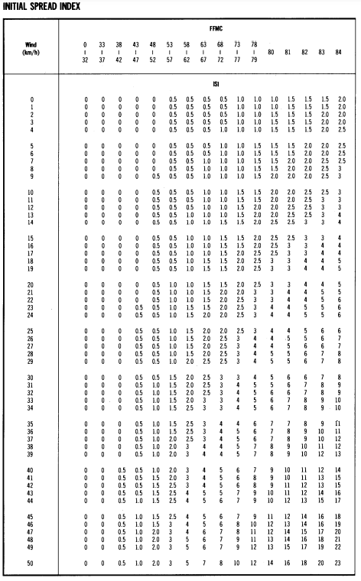

**Fig. 15:** ISI as determined by wind speed (km/h) and today’s FFMC value [29].



**Fig. 16:** BUI calculated from today’s DC and DMC values [29].

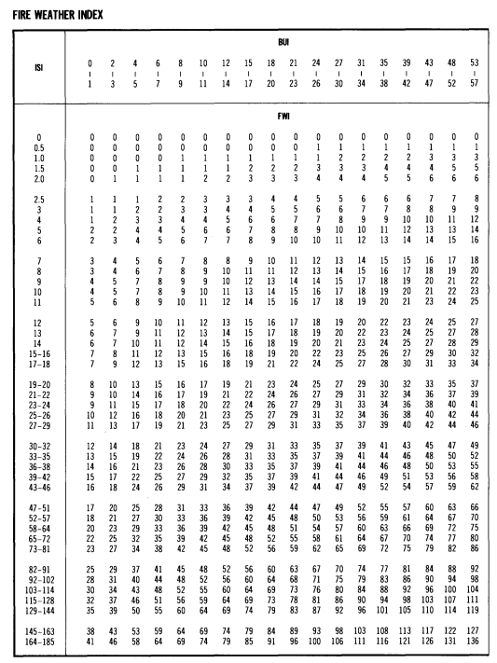

**Fig. 17:** FWI calculated from ISI and BUI [29].

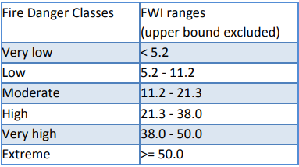

**Fig. 18:** Fire danger classes based on FWI value [31].

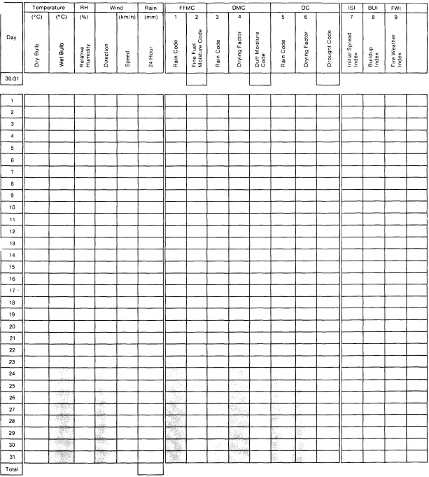

**Fig. 19:** An example worksheet to plug in all the calculated values [29].

#### **Fire Behavior Prediction (FBP) System**

The next step is to use the fire behavior prediction (FBP) system. The FBP system has a classification subsystem for fuel types [32]. The classifications begin at C-1, with the coniferous trees, and go to O-1, the grasses group (Fig. 20). The coniferous tree group is classified from C-1 through C-7. Any deciduous trees are in the D-1 fuel group. M-1 through M-4 is considered mixed-wood. S-1, S-2, and S-3 are tree debris, moss, and needles on the forest floor from various trees. Finally, O-1 is considered the open category, in which grasses and extremely scattered trees fall. There are two types of O-1 vegetation: O-1a, the matted grass after snowmelt in the spring, and O-1b, the dead grass found near the end of summer. The fuel type is determined by species, state of the vegetation, and whether the vegetation is dead or not. A core sample of the floor vegetation will aid in making this decision. A core sample is taken via a soil sample probe or corer.



**Fig. 20:** Descriptions of the classifications of fuel types from the Canadian Forest Fire Behavior Prediction System [32].

#### **Plant Identification**

To determine the species of vegetation at the sites in Montana, the application PlantNet will be used [33]. Just a few pictures of the plant need to be captured. Once these pictures are taken, the app will analyze them and determine the species. The app is used to determine the plant family, and then that family is searched within the Montana Field Guide’s [field guide citation] database in order to determine with more accuracy the specific species. Only trees, shrubs, and other prevalent plants are identified; these are the plants that will affect fire susceptibility.

**Drone Specifics**

Once the species is identified from ground pictures, the Unmanned Aerial Vehicle (UAV) will take aerial images of the designated research area. UAVs have been used for various types of research. Many unique characteristics of these UAVs make data collection much more efficient. UAVs have a flight time of about 30 minutes. This UAV is also said to be snow and rainproof with level 7 wind resistance. These features allow it to stay on track through wind speeds up to 31 mph [34, 35]. The UAV can be controlled with a mobile phone application called SD Fly [36]. It allows for the preparation of flight plans and grids ahead of time. The set height for the flight path is based on the height of the surrounding trees and vegetation, which is likely to be set at 80 meters. The drone will fly at one m/s. The flight pattern can also be adjusted as needed. Since a 90% overlap is optimal, the flight pattern lines will be 16 meters apart [37].

This research will utilize the SwellPro SplashDrone 4 with a GoPro Hero 3+ (Fig 21, 22). This small, hand-held camera makes taking images easy and efficient [38]. Smooth, and strong quality, the GoPro camera will take photos for 3D mapping, which will then be used to determine the tree crown area and diameter. The MAPIR Survey3 camera, also attached to the drone, has a 12 MP sensor and a sharp nonfish-eye lens that captures high-resolution images (Fig 23). It is around the size of a GoPro, allowing handheld use and easy attachment to the drone [39]. This camera will take pictures of the sites to calculate the Normalized Difference Vegetation Index (NDVI) values of the various vegetation and trees. First, the desktop MAPIR Camera Control system will analyze the aerial images [40]. This program interprets the photos alongside a sample photo and creates grayscale images. The pictures will be analyzed in ImageJ, a desktop software, to find NDVI values [41]. This software allows the manipulation of vegetation pictures to focus on individual trees or species. The NDVI can aid in the fuel type determination. As stated previously, many fuel types depend on dead vegetation. A low or even negative NDVI value indicates a low greenness level. In other words, the plant is not healthy or may be dead.

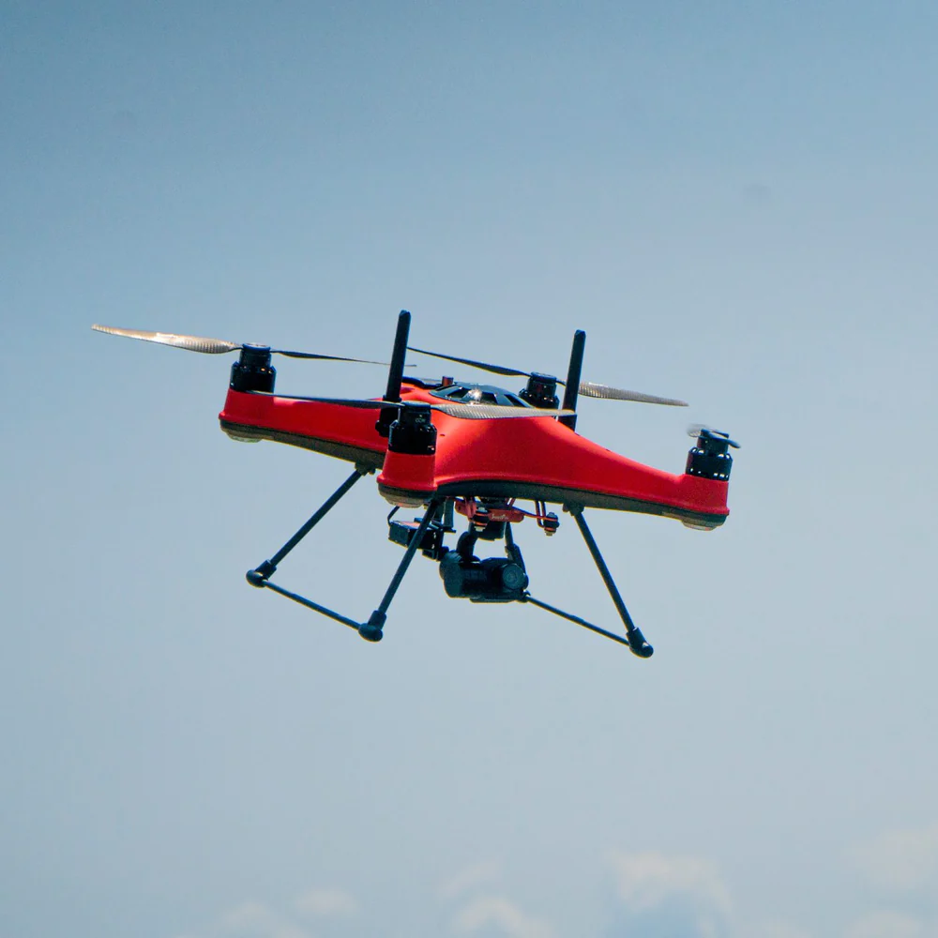

**Fig. 21:** The SwellPro SplashDrone 4 in flight[42].

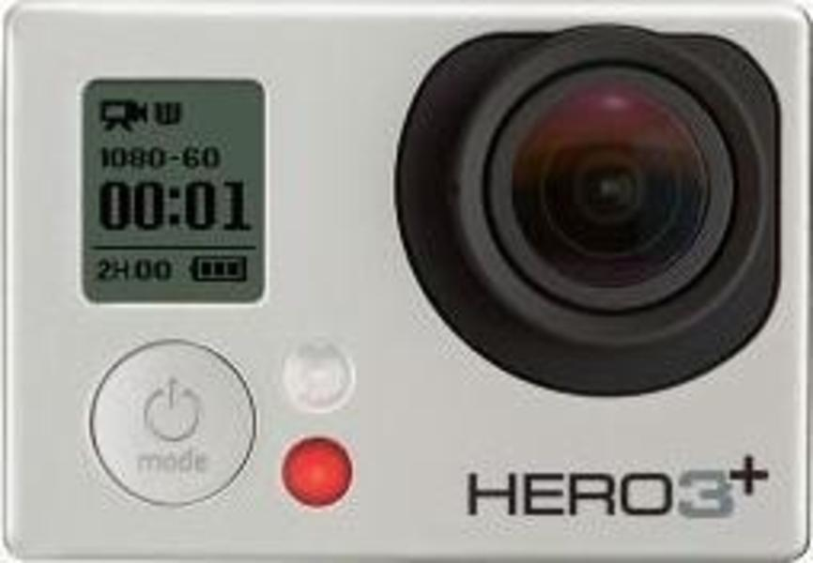

**Fig. 22:** Close-up of the GoPro Hero3+[38]

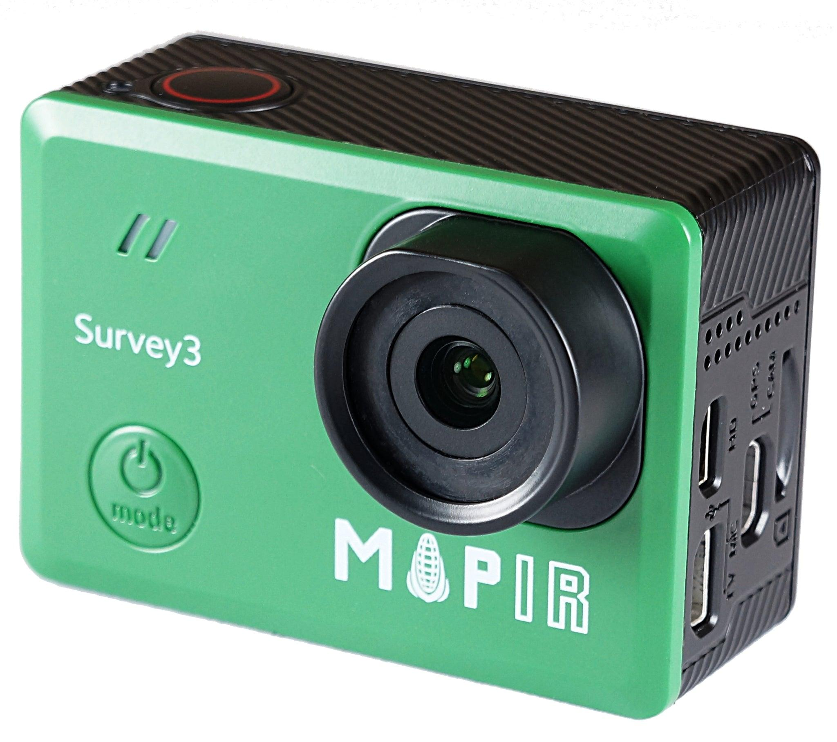

**Fig. 23:** Close-up of the MAPIR Survey3 camera [39]

#### **FBP System (Cont.)**

Once the fuel type is determined, the Fine Fuel Moisture Code (FFMC) or the Buildup Index (BUI) from the FWI section is plugged into an equation to calculate the predicted surface fire consumption (SFC) [32]. SFC has units of $kg/m^{2}$. The equations vary based on the selected fuel type (Table 3). The SFC can be calculated directly for fuel types C-1, C-2, M-3, M-4, and C-3 through C-6. For the C-7 fuel type, the forest floor consumption (FFC) and woody fire consumption (WFC) are calculated first. These two values are added to find the SFC for C-7.

| **Fuel Type** | **Equation** | **Fuel Type** | **Equation** |
| --- | --- | --- | --- |
| **C-1** | $SFC=1.5⋅[1-e^{(-0.230⋅[FFMC-81])}]$ | **C-7** | $FFC=2⋅[1-e^{(-0.104⋅[FFMC-70])}]$ |
| **C-2, M-3, M-4** | $SFC=5.0⋅[1-e^{(-0.0115⋅BUI)}]^{1.00}$ | **C-7** | $WFC=1.5⋅[1-e^{(-0.0201⋅BUI)}]$ |
| **C-3, C-4** | $SFC=5.0⋅[1-e^{(-0.0164⋅BUI)}]^{2.24}$ | **C-7, S-1, S-2, S-3** | $SFC=FFC+WFC$ |
| **C-5, C-6** | $SFC=5.0⋅[1-e^{(-0.0149⋅BUI)}]^{2.48}$ |  |  |

**Table 3**: Equations for calculating the surface fire consumption (SFC) of C-1 through C-7, M-3, and M-4 fuel types [32].

The equations for D-1, M-1, and M-2 fuel types rely on the PC. (Table 4). PC stands for percent conifer concentration. PH stands for percent hardwood concentration, which can be determined via the NDVI values of the vegetation. A 3D map can also aid in finding these two values. S-1, S-2, and S-3 fuel types need two equations to calculate the FFC and WFC. The last equation in the previous table shows how to find the SFC value for these fuel types. Finally, the SFC for O-1 fuel types equals the grass fuel load (GFL). For grasses, the standard GFL is considered to be 0.3 $kg/m^{2}$.

| **Fuel Type** | **Equation** | **Fuel Type** | **Equation** |
| --- | --- | --- | --- |
| **D-1** | $SFC=1.5⋅(1-e^{(-0.0183⋅BUI)}]$ | **S-2** | $FFC=10.0⋅[1-e^{(-0.013⋅BUI)}]$ |
| **M-1, M-2** | $SFC=[\frac{PC}{100}⋅(SFC for C2)$ $+[\frac{PH}{100}⋅(SFC for D1)]$ | **S-2** | $WFC=6.0⋅[1-e^{(-0.060⋅BUI)}]$ |
| **S-1** | $FFC=4.0⋅[1-e^{(-0.025⋅BUI)}]$ | **S-3** | $FFC=12.0⋅[1-e^{(-0.0166⋅BUI)}]$ |
| **S-1** | $WFC=4.0⋅[1-e^{(-0.034⋅BUI)}]$ | **S-3** | $WFC=20.0⋅[1-e^{(-0.0210⋅BUI)}]$ |

**Table 4:** Equations for calculating SFC for fuel types D-1, M-1, M-2, and S-1 through S-3 [32].

The next portion of the FBP system consists of calculating the possible rate of spread of a wildfire. The ISI from the FWI portion is plugged into a distinct equation to determine the initial rate of spread (RSI). The predicted RSI value is equal to the head fire spread rate. Equation 1 shows the general equation for the RSI. The ISI stays the same, but the variables *a, b,* and *c* differ according to fuel type (Fig. 24). The values for C-1 through C-7, D-1, S-1 through S-3, and O-1 are given.

$RSI=a⋅[1-e^{(-b⋅ISI)}]^{c}$

(1)

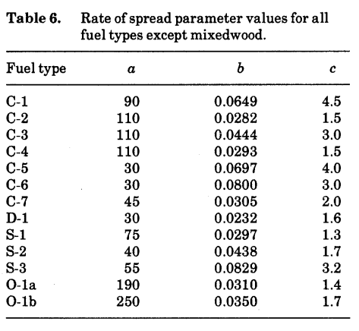

**Fig. 24:** RSI *a, b,* and *c* variable values per fuel type [32].

The variables for the mixed wood fuel types (M-1 through M-4) are calculated through a series of equations [32]. Since these forests consist of many species of trees and vegetation, the RSI values of the several fuel types are factored in. Fuel type M-1 uses Equation 2 to determine the RSI. M-2 uses Equation 3. For fuel types M-3 and M-4, the general equation for the RSI is used, but the values for the three variables need to be calculated. Equations 4, 5, and 6 are for M-3, and Equations 7 and 8 are used for M-4 fuel types. The *b* value for M-4 types is 0.0404. PDF refers to the percent dead balsam fir. PC is the percent conifer concentration. PH is the percent hardwood concentration. UAV aerial pictures, NDVI, and 3D mapping will help determine these values.

$RSI=[\frac{PC}{100}⋅(RSI for C2)]+[\frac{PH}{100}⋅(RSI for D1)]$

(2)

$RSI=[\frac{PC}{100}⋅(RSI for C2)]+0.2⋅[\frac{PH}{100}⋅(RSI for D1)]$

(3)

$a=170⋅e^{(\frac{-35.0}{PDF})}$

(4)

$b=0.082⋅e^{(\frac{-36.0}{PDF})}$

(5)

$c=1.698-(0.00303⋅PDF)$

(6)

$a=140⋅e^{(\frac{-35.5}{PDF})}$

(7)

$c=3.02⋅e^{(-0.00714⋅PDF)}$

(8)

The RSI equation (Equation 1) is inaccurate for O-1 fuel types [32]. It needs to be corrected with the curing factor (CF). The CF is determined by the degree of curing. The degree of curing is the percentage of grasses that have browned. NDVI will help work out the CF percentage. Since NDVI measures how healthy or green vegetation is, a low NDVI should indicate dead vegetation. The CF is found through Equation 9, where C is the percentage of curing. The updated equation for the rate of spread (ROS) for O-1 fuel types is displayed in equation 10. The *a, b,* and *c* values are pulled from Fig. 24.

$CF=(0.2⋅C)-1.0$

(9)

$ROS=a⋅[1-e^{(-b⋅ISI)}]^{c}⋅CF$

(10)

Another variable that needs to be accounted for is the buildup effect (BE). The BE measures the current BUI and the average BUI for the fuel type (Fig. 25). The BE can be calculated via Equation 11. ${BUI}_{0}$ is the average BUI per fuel type, and *q* is the maximum possible spread rate. By combining the RSI and the BE, the ROS in m/min can be found (Equation 12). Of course, the ROS differs by fuel type since the RSI and BE have separate equations per fuel type.

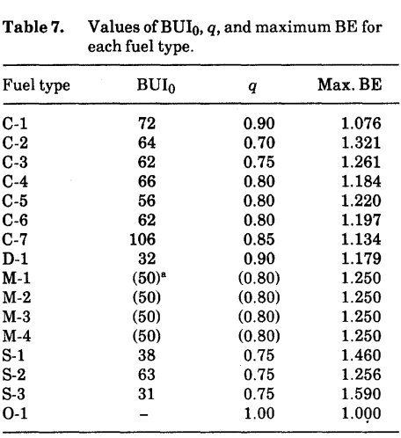

**Fig. 25:** Average BUI and *q* value per fuel type [32].

$BE=e^{[50⋅ln(q)⋅(\frac{1}{BUI}-\frac{1}{{BUI}_{0}})]}$

(11)

$ROS=RSI⋅BE$

(12)

Right now, the predicted values approximate surface fire behavior. Eventually, the tree crowns will also catch on fire and cause a shift in the rate of spread [32]. The critical surface fire intensity (CSI) is the threshold when the fire spreads to the crown of the trees. To calculate the CSI (Equation 13), the crown base height (CBH) and the foliar moisture content (FMC) need to be assessed (Fig. 26).

$CSI=0.001⋅CBH^{1.5}⋅[460+(25.9⋅FMC)]^{1.5}$

(13)

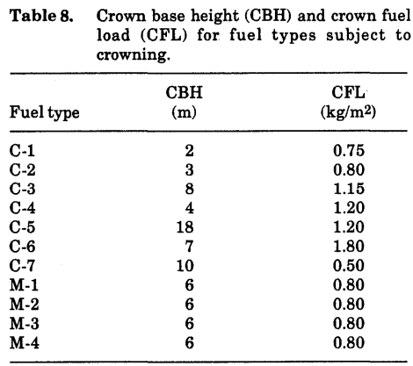

**Fig. 26:** Approximations for CBH according to fuel type [32].

FMC is quantified through a series of equations that include the following: latitude (LAT), normalized latitude (LATN), longitude (LON), Julian date ($D_{j}$), and date of minimum foliar moisture content (ND)[32]. The ND is based on Equations 14 and 15, which use the LAT and LATN of the research sites. Depending on the ND value calculated in Equation 16, any of the three equations can be used to find the FMC. Equation 17 is for an ND value less than 30. Equation 18 is for ND values between 30 and 50. Finally, if the ND value is more than, or equal to, 50, the FMC value equals 120.

$LATN=46+23.4⋅e^{-0.0360⋅(150-LON)}$

(14)

$D_{0}=151⋅(\frac{LAT}{LATN})$

(15)

$ND=|D_{j}-D_{0}|$

(16)

$FMC=85+0.0189⋅ND^{2}$

(17)

$FMC=32.9+(3.17⋅ND)-(0.0288⋅ND^{2}$

(18)

Once the CSI is calculated, it needs to be converted to a rate of spread value [32]. The critical surface fire spread rate (RSO) is defined by an equation with the CSI and surface fuel consumption (SFC) values (Equation 19). The two spread rate values, ROS (measured in m/min) and RSO, become the crown fraction burned (CFB) (Equation 20). The CFB is necessary to compute the crown fuel consumption (CFC) ($kg/m^{2}$). The CFC is found by multiplying the CFB by the crown fuel load (CFL) (Fig. 25). This is summed in Equation 21. For M-1 and M-2 fuel types, the factor $\frac{PC}{100}$ is multiplied with the calculated CFC to scale it more accurately. The CFC is then inserted into an equation to determine the total fuel consumption (TFC) ($kg/m^{2}$). The TFC is a sum of the SFC and CFC (Equation 22).

$RSO=\frac{CSI}{300 ⋅ SFC}$

(19)

$CFB=1-e^{-0.23 ⋅ (ROS-RSO)}$

(20)

$CFC=CFL⋅CFB$

(21)

$TFC=SFC+CFC$

(22)

Finally, the FBP system predicts the fire intensity (FI). FI is measured in kW/m, where kW is 1,000 watts of mechanical energy [33]. The components of FI are predicted fuel consumption (FC) and rate of fire spread in m/min (ROS) (Equation 23). The FC can be either the TFC or SFC values. The type of fire is based on the CFB. A CFB of less than 0.1 indicates a surface fire. CFB values from 0.1 to 0.89 predict an intermittent crown fire. Values of 0.9 or higher predict a continuous crown fire.

$FI =300⋅FC⋅ROS$

(23)

FBP can also predict the wildfire’s temperature (T) and ignition heat (h). Temperature is calculated by factoring in the foliar moisture content (FMC) value (Equation 24). The wildfire temperature is measured in degrees Kelvin. The FMC value is factored into an equation to find the ignition heat (Equation 25). The heat of ignition refers to the temperature of the fire when it first begins. This temperature is also in Kelvin. Although this information is nonessential for quantifying the FI, it can provide valuable insights when predicting the precise behavior of a fire.

$T=1500-(2.75⋅FMC)$

(24)

$h=460+(25.9⋅FMC)$

(25)

### **Results**

| **Date** | **Dry Bulb (C)** | **Wet Bulb (C)** | **Wind (kph)** | **RH (%)** | **24-hr Rain (mm)** | **FFMC** | **DMC** | **DC** | **ISI** | **BUI** | **FWI** |
| --- | --- | --- | --- | --- | --- | --- | --- | --- | --- | --- | --- |
| **5/17** | 13.3 | 7.2 | 20.28 | 41 | 5.84 | 88 | 18 | 50 | 15 | 19 | 19 - moderate |
| **5/18** | 14.3 | 8.2 | 9.38 | 19 | 0 | 90 | 21 | 55 | 9 | 21 | 14 - moderate |
| **5/19** | 8.5 | 5.5 | 1.31 | 59 | 24.6 | 87 | 9 | 17 | 3 | 9 | 3 - very low |
| **5/20** | 13 | 7.6 | 31 | 38 | 3.55 | 88 | 9 | 20 | 4 | 10 | 4 - very low |

**Table 8**: The collected data for the research done at GF1.

| **Date** | **Dry Bulb (C)** | **Wet Bulb (C)** | **Wind (kph)** | **RH (%)** | **24-hr Rain (mm)** | **FFMC** | **DMC** | **DC** | **ISI** | **BUI** | **FWI** |
| --- | --- | --- | --- | --- | --- | --- | --- | --- | --- | --- | --- |
| **5/17** | 15.9 | 9.6 | 12.11 | 49 | 5.84 | 89 | 18 | 50 | 10 | 19 | 14 - moderate |
| **5/18** | 14.2 | 8.2 | 12.67 | 19.1 | 0 | 90 | 21 | 55 | 12 | 21 | 17 - moderate |
| **5/19** | 8.9 | 5.7 | 1.55 | 56 | 24.6 | 87 | 9 | 17 | 3 | 9 | 3 - very low |
| **5/20** | 14 | 8.2 | 9.9 | 38 | 3.55 | 88 | 9 | 20 | 7 | 10 | 8 - low |

**Table 9**: The collected data for the research done at GF2.

| **Date** | **Dry Bulb (C)** | **Wet Bulb (C)** | **Wind (kph)** | **RH (%)** | **24-hr Rain (mm)** | **FFMC** | **DMC** | **DC** | **ISI** | **BUI** | **FWI** |
| --- | --- | --- | --- | --- | --- | --- | --- | --- | --- | --- | --- |
| **5/25** | 17.3 | 11.3 | 16.09 | 45 | 2.03 | 87 | 17 | 80 | 6 | 24 | 10 - low |
| **5/26** | 18.4 | 11.3 | 22.53 | 32 | 0.5 | 89 | 21 | 86 | 12 | 27 | 19 - moderate |
| **5/27** | 25.3 | 15.5 | 6.44 | 28 | 0 | 93 | 27 | 93 | 9 | 30 | 15 - moderate |

**Table 10**: The collected data for the research done at M1.

| **Date** | **Dry Bulb (C)** | **Wet Bulb (C)** | **Wind (kph)** | **RH (%)** | **24-hr Rain (mm)** | **FFMC** | **DMC** | **DC** | **ISI** | **BUI** | **FWI** |
| --- | --- | --- | --- | --- | --- | --- | --- | --- | --- | --- | --- |
| **5/25** | 20.1 | 12.5 | 16.9 | 38 | 2.03 | 89 | 17 | 80 | 9 | 24 | 14 - moderate |
| **5/26** | 20 | 12 | 20.92 | 28 | 0.5 | 91 | 21 | 86 | 14 | 27 | 21 - moderate |
| **5/27** | 24.5 | 15.3 | 8.05 | 29 | 0 | 91 | 26 | 93 | 7 | 30 | 13 - moderate |

**Table 11**: The collected data for the research done at M2.

#### **Plant Identification**

The plants listed below are the primary plants of each ecosystem. These plants are either extremely common within the ecosystem or are large in size, both affecting fire susceptibility. Non-listed grasses were present mainly in the GF sites, and verified greatly but generally were within the Poaceae and Cyperaceae families. All of the sites were classified as coniferous forest.

| GF1 | Plants |
| --- | --- |
| 1. | Rocky Mountain Juniper, *Juniperus scopulorum* |
| 2. | Common Juniper, *Juniperus communis,* **Shrub** |
| 3. | Creeping Juniper, *Juniperus horizontalis,* **Shrub** |
| 4. | Douglas Fir, *Pseudotsuga menziesii* |
| 5. | Lodgepole Pine, *Pinus contorta* |
| 6. | Ponderosa Pine, *Pinus ponderosa* |

**Table 12:**

| GF2 | Plants |
| --- | --- |
| 1. | Rocky Mountain Juniper, *Juniperus scopulorum* |
| 2. | Common Juniper, *Juniperus communis,* **Shrub** |
| 3. | Creeping Juniper, *Juniperus horizontalis,* **Shrub** |
| 4. | Douglas Fir, *Pseudotsuga menziesii* |
| 5. | Ponderosa Pine, *Pinus ponderosa* |
| 6. | Quaking Aspen, *Populus tremuloides* |

**Table 13:**

| M1 | Plants |
| --- | --- |
| 1. | Douglas Fir, *Pseudotsuga menziesii* |
| 2. | Ponderosa Pine, *Pinus ponderosa* |
| 3. | Arrowleaf Balsamroot, *Balsamorhiza sagittata* |
| 4. | Silvery Lupine, *Lupinus argenteus* |
| 5. | Snowberry, *Symphoricarpos albus* |

**Table 14:**

| M2 | Plants |
| --- | --- |
| 1. | Douglas Fir, *Pseudotsuga menziesii* |
| 2. | Ponderosa Pine, *Pinus ponderosa* |
| 3. | Rocky Mountain Maple, *Acer glabrum* |
| 4. | Arrowleaf Balsamroot, *Balsamorhiza sagittata* |
| 5. | Chokecherry, *Prunus virginiana* |

**Table 15:**

#### **NDVI Compared to FWI for Great Falls and Missoula, Montana**

| **Date** | **NDVI** | **FWI** |
| --- | --- | --- |
| **05/20, Site 1** | 0.306 | 4 - very low |
| **05/20, Site 2** |  | 8 - low |
| **05/26, Site 1** | 0.426 | 19 - moderate |
| **05/26, Site 2** | 0.414 | 21 - moderate |

**Table 16:** NDVI for the dates flown compared to FWI. The Pearson-R correlation value for these data sets is _______.

#### **Graphs Comparing Collected Variables to FWI**

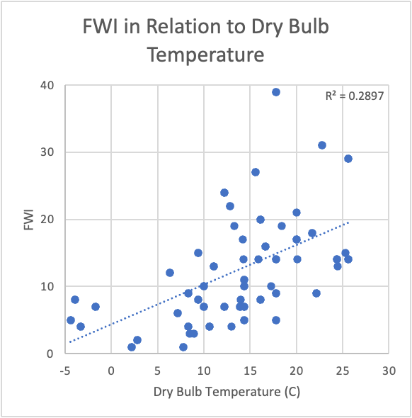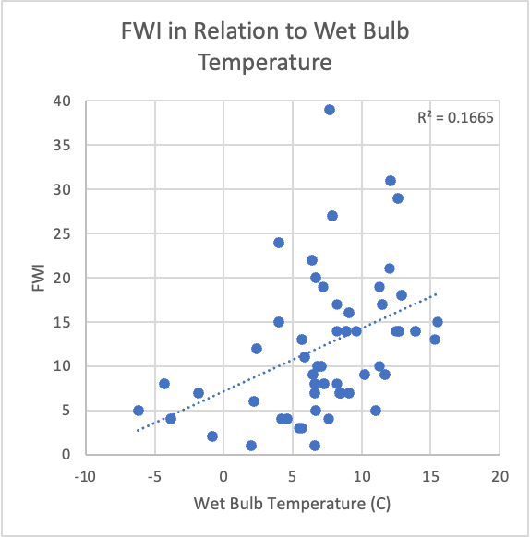

**Figure 27**: Dry bulb temperatures and wet bulb temperatures compared to resulting FWI values.

Figure 27 is composed of two separate variables, dry bulb temperature, and wet bulb temperature, when compared to the resulting FWI calculations from this research experiment. The graph located on the left relates dry bulb temperature in degrees Celsius to the resulting FWI values. The Pearson-R value for these two variables was 0.538. The graph located on the right compares wet bulb temperature in degrees Celsius to the resulting FWI values. The Pearson-R value for these two variables was 0.408.

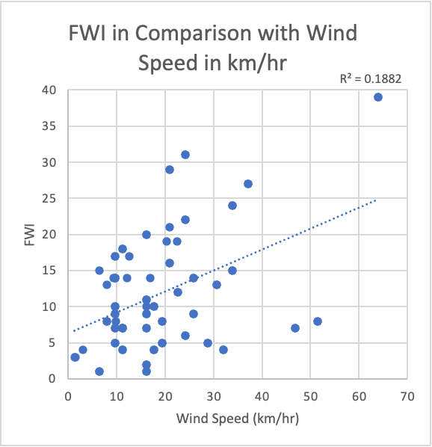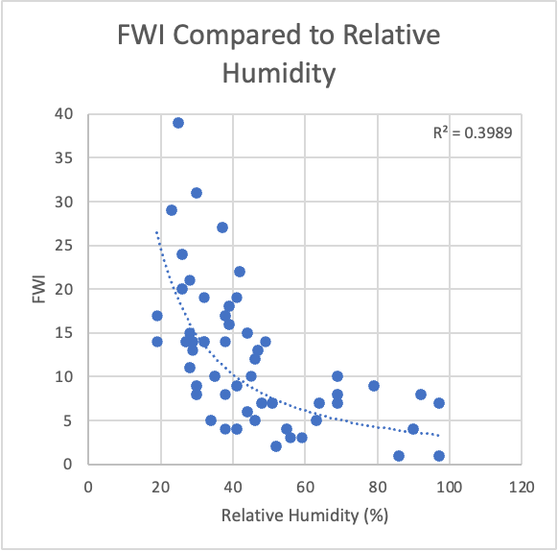

**Figure 28**: Wind speed in km/hr and percentage relative humidity in relation to resulting FWI values.

Figure 28 is composed of two separate variables, wind speed, and relative humidity, compared to the resulting FWI values for this experiment. The graph on the left relates wind speed in km/hr to the resulting FWI values. The Pearson-R value for these two variables was 0.434. The graph on the right compares the relative humidity percentage to the resulting FWI calculations. The Pearson-R value for this comparison was -0.578.

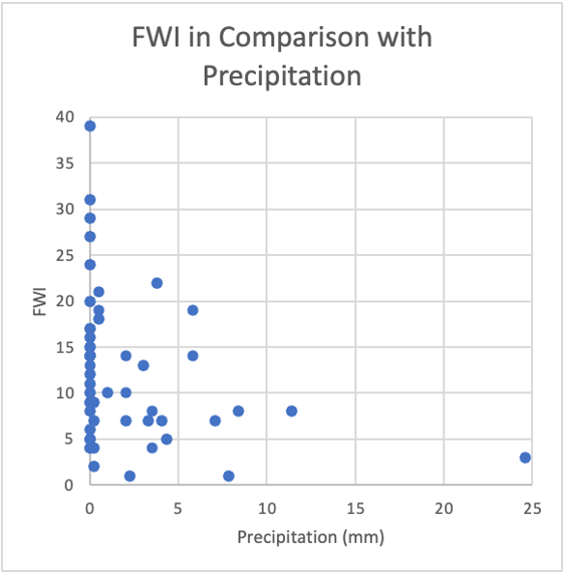

**Figure 29**: 24-hour precipitation compared to resulting FWI calculations. The Pearson-R value for this comparison was -0.295.

#### **Weather Variables Versus Fire Behavior Prediction (FBP) System Variables**

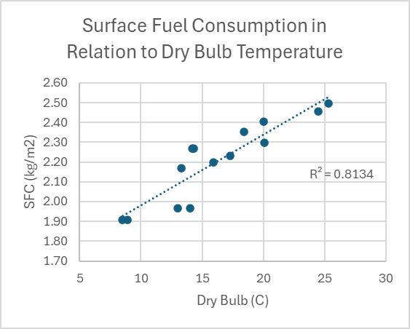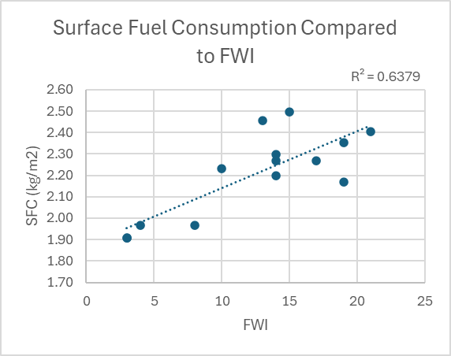

**Figure 30:** Weather Variables of the FWI system compared to Surface Fuel Consumption (SFC).

Figure 30 is composed of two different variables versus the Surface Fuel Consumption variable of the FBP system. The graph on the left relates the SFC to the collected dry bulb temperature. The Pearson-R value for these two variables was 0.902. The graph on the right relates the SFC to FWI. The Pearson-R correlation value for these variables is 0.799, or 0.800 if rounded.

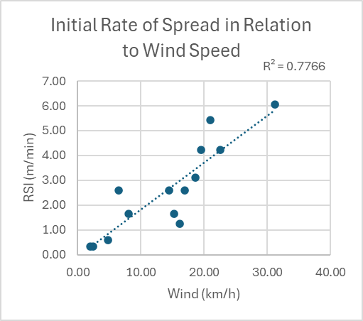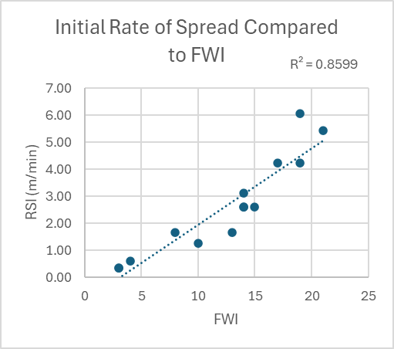.

**Fig. 31:** Weather Variables of the FWI system versus Initial Rate of Spread (RSI).

Figure 31 is composed of two different variables versus the Initial Rate of Spread variable of the FBP system. The graph on the left relates the RSI to the collected wind speed in km/hr. The Pearson-R value for these two variables was 0.881. The graph on the right relates the RSI to FWI. The Pearson-R correlation value for these variables is 0.927.

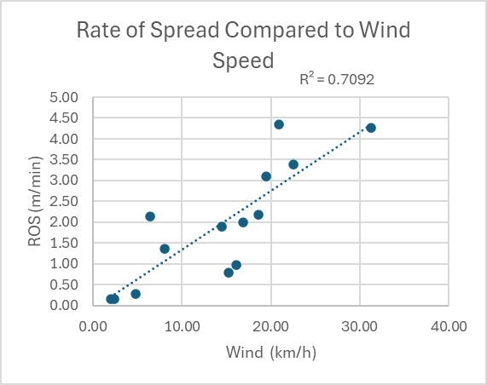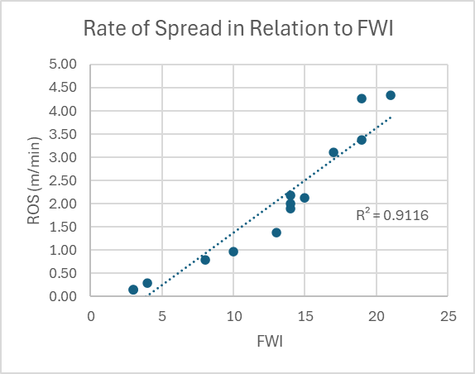

**Fig. 32:** Weather variables of the FWI system versus Rate of Spread (ROS).

Figure 32 is composed of two different variables versus the Rate of Spread variable of the FBP system. The graph on the left relates the ROS to the collected wind speed in km/hr. The Pearson-R value for these two variables was 0.842. The graph on the right relates the ROS to FWI. The Pearson-R correlation value for these variables is 0.955.

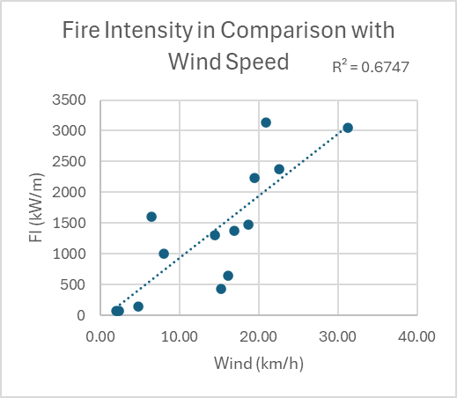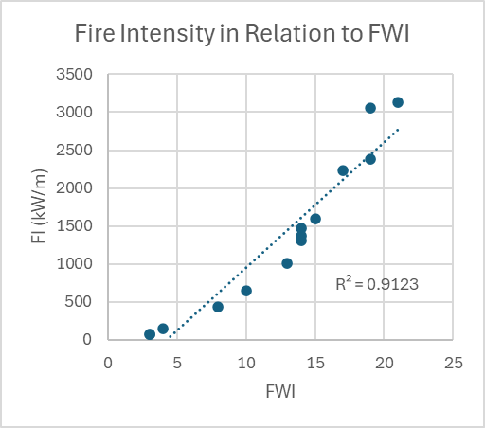

**Fig. 33:** Weather variables of the FWI system compared to Fire Intensity (FI).

Figure 33 is composed of two different variables versus the Fire Intensity variable of the FBP system. The graph on the left relates the FI to the collected wind speed in km/hr. The Pearson-R value for these two variables was 0.821. The graph on the right relates the FI to FWI. The Pearson-R correlation value for these variables is 0.955.

#### **FBP Crown Fires**

| **Date** | **Site** | **CFB** | **Fire Type** |
| --- | --- | --- | --- |
| 05/17 | GF1 | 0.430951 | Intermittent crown fire |
| 05/18 | GF1 | 0.0396847 | Surface fire |
| 05/17 | GF2 | 0.086967944 | Surface fire |
| 05/18 | GF2 | 0.271 | Intermittent crown fire |
| 05/26 | M2 | 0.369 | Intermittent crown fire |

**Table 17:** Date, site, crown fraction burned, and fire type for days when crowning was predicted via the FBP system.

### **Discussion**

The NDVI values found from drone data collection were found not to be an accurate indicator of fire susceptibility. NDVI is used to find the curing factor, or percent brownness, of vegetation. The lower NDVI values get, the closer the vegetation is to dying. Fire susceptibility, or FWI, should increase as vegetation gets closer to dying, which should manifest as a negative correlation between NDVI and FWI. However, based on the data collected from the ground to determine the FWI and the drone data used to calculate NDVI, there is a strong positive correlation between the two variables.

The goal of this research was to determine the susceptibility of a location to wildfire. This research used the FWI system of the CFFDRS to determine this susceptibility. The FWI values were arranged by the system so that they could be categorized into verbal descriptions of fire risk. The graphs in the results section could be used as predictors of FWI. To be able to say that the correlation is significant, the Pearson correlation r-value should be outside of the ±0.2006 range. This is true for the graphs in the ‘Graphs Comparing Collected Variables to FWI’ section. There are 95 data points, so the degrees of freedom is 94. Since all of the data sets have R-values outside of ±0.2006, these graphs and their lines can be used as predictors. A person could predict the FWI, or fire susceptibility, of a region using these graphs.

The FBP system predicts the surface fuel consumption in kg/m^2. initial spread rate (RSI), which is the rate of spread for the head fire at the start of ignition. It also predicts the rate of spread (ROS), which is the fire’s spread rate after ignition. Importantly, it predicts FI (fire intensity) and CSI (critical surface fire intensity for crowning). The CSI is the point at which the wildfire begins to crown and engulf the trees. If the CSI is greater than the FI, then the fire will begin to crown. On five of the dates, crowning was predicted. Table 17 in the results section highlights the crown fraction burned (CFB) and the type of fire for each day. On days with only surface fire predictions, the fire may crown in some places, but will not be continuous.

The same could be said for the graphs in the ‘Weather Variables Versus Fire Behavior Prediction (FBP) System Variables’ as the graphs in the FWI section. This section compares weather variables like dry bulb temperature or wind speed versus how fire behaves. These graphs could be used as predictors of fire behavior characteristics. To be able to say that the correlation is significant, the Pearson correlation r-value should be outside of the ±0.532 range. The sets of data presented here have r-values outside of this range, so they are significantly correlated. Therefore, these graphs can be used as predictors of things like the rate of spread and fire intensity. Fire susceptibility and behavior can be accurately predicted through these graphs and results.

#### **Complications**

During data collection, several complications occurred, which made collecting and analyzing the results difficult. In Great Falls, which was the first testing area, there was excessive wind, and as a result, the drone could not be flown. Consequently, the NDVI could not be determined for that day. Precipitation that occurred during data collection decreased the indices which then decreased the FWI values. When calculated FWI values were considered low, which is when the values ranged between 1 and 11, the FBP system can not be calculated. Therefore, precipitation was considered to be a complication with calculating the FBP because, occasionally, the values were too low to calculate acceptable values.

On the last day of testing in the Great Falls locations, one of the drones got stuck in a tree. This made the Missoula testing, the testing that occurred after the Great Falls testing, very difficult with multiple groups trying to use the drone and scheduling conflicts. The researchers switched the data collection from determining NDVI on all 4 testing days at each site to only one day at each site. This resolved scheduling conflicts with the other research groups. Another complication that occurred in Missoula was the fact that testing could not be conducted on the first day because the originally chosen sites were inaccessible. The road to get to the site, which was seemingly accessible according to Google Maps, was on the side of a cliff. Therefore, these sites could not be accessed with the vehicle used for transportation. New sites were chosen for the following days of testing. On the second day of testing in Missoula, the anemometer, a tool used to determine wind speed, was found broken and could no longer be utilized for the rest of the testing period. The Apple Weather App was then utilized to obtain the wind speed for the rest of the testing period, which was all three days in Missoula. Because the wind speed data was not collected accurately for all three days of testing, the Missoula data alone could not be assessed and analyzed to make clear conclusions.

Complications also occurred during the entirety of testing at both locations, Great Falls and Missoula. A plant predictor app, also known as Plantnet, was inaccurate as it was predicting the plants with a low percentage. An online Montana field guide was utilized as the primary plant predictor instead of Plantnet.

### **Conclusion**

Forest fires in the state of Montana have proven to be both historically and currently detrimental to the surrounding environments. This study supported concerns regarding the fire susceptibility of forests located in Great Falls and Missoula, Montana. During this study, a variety of variables were accounted for. These variables were collected using drone imaging along with ground data. A UAV drone was utilized to obtain curing values for each plot. Soil samples were obtained with the use of a systematic sampling method. These samples were collected to determine the percent moisture content of each site. An anemometer, along with a meteorological website, were used to assist in determining the wind speed. A temperature and humidity meter was used to determine the relative humidity. These variables, along with other meteorological-related data, were incorporated into the Canadian Forest Fire Danger Rating System (CFFDRS). Using the fire weather index (FWI) and fire behavior prediction (FBP) system algorithms, weather variables were obtained from data collection, such as relative humidity, precipitation, temperature, and wind speed. These variables were then incorporated into the five components: Fine Fuel Moisture Code (FFMC), Duff Moisture Code (DMC), Drought Code (DC), Initial Spread Index (ISI), and Buildup Index (BUI). The Pearson test was used to compare all these specific variables and components to determine which of them affect specific fire characteristics. These specific fire characteristics are Initial rate of spread (RSI), rate of spread (ROS), surface fire consumption (SFC), and fire intensity (FI). Out of all of these variables and components, FWI and wind were found to affect the spread of fire the most by having high Pearson-R values for most or all of these fire characteristics.

### **Acronym Table**

| **Acronym** | **Definition** | **Acronym** | **Definition** |
| --- | --- | --- | --- |
| NDVI | Normalized Difference Vegetation Index | ROS | Rate Of Spread |
| FWI | Fire Weather Index | BE | Buildup Effect |
| FBP | Fire Behavior Prediction | CSI | Critical Surface fire Intensity |
| RH | Relative Humidity | CBH | Crown Base Height |
| FFMC | Fine Fuel Moisture Code | FMC | Foliar Moisture Content |
| DMC | Duff Moisture Code | LAT | Latitude |
| DC | Drought Code | LATN | Normalized Latitude |
| ISI | Initial Spread Index | LON | Longitude |
| BUI | Buildup Index | ND | Date of minimum foliar moisture content |
| UAV | Unmanned Aerial Vehicle | RSO | Critical Surface Fire Rate Of Spread |
| SFC | Surface Fire Consumption | CFB | Crown Fraction Burned |
| FFC | Forest Floor Consumption | CFC | Crown Fuel Consumption |
| WFC | Woody Fire Consumption | CFL | Crown Fuel Load |
| PC | Percent Conifer concentration | TFC | Total Fuel Consumption |
| PH | Percent Hardwood concentration | FI | Fire Intensity |
| GFL | Grass Fuel Load | FC | Fuel Consumption |
| RSI | Initial Rate of Spread | T | Temperature |
| CF | Curing Factor | h | Heat of ignition |

**Table 18:** Abbreviations of terms in order of appearance.

### **References**

[1] Bohn, F. J. and Huth, A. "The importance of forest structure to biodiversity–productivity relationships." *Royal Society Open Science,* **2017**, 4, 1,160521. [doi: 10.1098/rsos.160521.](https://www.ncbi.nlm.nih.gov/pmc/journals/2753/)

[2] Moore, A. "Explainer: How Wildfires Start and Spread." *College of Natural Resources News, NC State University,* **2021.** [www.cnre.ncsu.edu/news/2021/12/explainer-how-wildfires-start-and-spread/.](http://www.cnre.ncsu.edu/news/2021/12/explainer-how-wildfires-start-and-spread/.)

[3] "Wildfire Causes and Evaluations." Wildland Fire Learning In Depth Series, *National Park Service,* **2022.**

[www.nps.gov/articles/wildfire-causes-and-evaluations.htm](http://www.nps.gov/articles/wildfire-causes-and-evaluations.htm).

[4] Földi, L. and Kuti, R. “Characteristics of Forest Fires and Their Impact on the Environment.” *Academic and Applied Research in Military and Public Management Science*, **2016**, *15*, 5-17.<https://real.mtak.hu/145913/1/1_AARMSVol.15No.12016517.pdf>

[5] Velayati, A. H.; Boloorani, A. H.; Kiavarz, M.; Samani, N. N.; Alavipanah, S. K. “Spatiotemporal Analysis of Wildfire in the Tigris and Euphrates Basin: A Remote Sensing-based Wildfire Potential Mapping”, Remote Sensing Applications: Society and Environment, **2024**, 101150. [doi:10.1016/j.rsase.2024.101150](https://www.sciencedirect.com/science/article/abs/pii/S2352938524000144).

[6] “Montana’s Ecosystems,” *Montana Institute of Ecosystems.* <https://www.montana.edu/ioe/montanaecosystems.html.>

[7] “Montana Weather in May.” *World Weather & Climate Information,* **2020.** <https://weather-and-climate.com/region-averages-montana-us,United-States-of-America-May#weather-map.>

[8] Keegan, C. E.; Fiedler, C. E.; Morgan, T. A. “Wildfire in Montana: Potential Hazard Reduction and Economic Effects of a Strategic Treatment Program.” Forest Products Journal, **2004**, 21-25.

[9629_Keegan.vp (umt.edu)](https://www.bber.umt.edu/pubs/forest/fire/Wildfire_In_Montana.pdf)

[9] Stadwiser, B. “How Changes in Climate, Fuels and Human Activity Are Driving Longer, More Destructive Fire Seasons – and Health Implications for Those Living in the West.” *Montana Inbre,* **2021,** 2-6. <https://brin.montana.edu/documents/inbre_newsletter_fall_2021_optimized.pdf.>

[10] Halofsky, J.E.; Peterson, D.L.; Harvey, B.J. “Changing wildfire, changing forests: the effects of climate change on fire regimes and vegetation in the Pacific Northwest, USA.” *Fire Ecology*, **2020**, 16, 4. <https://doi.org/10.1186/s42408-019-0062-8>

[11] Westerling, A. L.; Hidalgo, H. G.; Cayan, D. R.; Swetnam, T. W. “Warming and Earlier Spring Increase Western U.S. Forest Wildfire Activity”, *Science,* **2006,** 313, 940-943. DOI:[10.1126/science.1128834](https://doi.org/10.1126/science.1128834)

[12] Holden, Z.; Swanson, A.; Luce, C.; Jolly, W.; Maneta, M.; Oyler, J.; Warren, D.; Parsons, R.; Affleck, D. “Decreasing Fire Season Precipitation Increased Recent Western US Forest Wildfire Activity,” *The National Academy of Sciences,* **2018,** 36, E8349 - E8357. <https://doi.org/10.1073/pnas.1802316115>

[13] Agbeshie, A. A.; Abugre, S.; Atta-Darkwa, T.; Awuah, R. “A Review of the Effects of Forest Fire on Soil Properties,” *Journal of Forestry Research,* **2022,** 33, 1419–1441. <https://doi.org/10.1007/s11676-022-01475-4>

[14] Zhai, J.; Ning, Z.; Dahal, R.; Yang, S. “Wildfire Susceptibility of Land Use and Topographic Features in the Western United States: Implications for the Landscape Management,” *Forests,* **2023**, 14, 807. <https://doi.org/10.3390/f14040807>

[15] Westerling, A. L. “Increasing western US forest wildfire activity: sensitivity to changes in the timing of spring,” *Philosophical Transactions of the Royal Society,* **2016,** 3712015017820150178. [http://doi.org/10.1098/rstb.2015.0178](https://doi.org/10.1098/rstb.2015.0178)

[16] “Fire Behavior Field Reference Guide, PMS 437,” *National Wildfire Coordinating Group,* **2021.** <https://www.nwcg.gov/publications/pms437>

[17] “CFFDRS System Overview” *Fire Behavior Field Reference Guide, PMS 437,* **2021.** <https://www.nwcg.gov/publications/pms437/cffdrs/overview>

[18] ZMT “Creating Forest Inventories with Drones and Artificial Intelligence,” *Biotechnology*, **2023.** <https://phys.org/news/2023-08-forest-drones-artificial-intelligence.html.>

[19] Barrios-Calderón, R. d. J.; Mata, D. I.; Garnica, J. G. F.; Torres, J. R. “Forest Fuel Bed Variation in Tropical Coastal Freshwater Forested Wetlands Disturbed by Fire,” *Forests,* **2024,** 15, 158. <https://doi.org/10.3390/f15010158>

[20] Reilly, M. J.; Dunn, C. J.; Meigs, G. W.; Spies, T. A.; Kennedy, R. E.; Bailey, J. D.; Briggs, K. “Contemporary Patterns of Fire Extent and Severity in Forests of the Pacific Northwest, USA (1985–2010),” *Ecosphere,* **2017**. DOI: [10.1002/ecs2.1695](https://doi.org/10.1002/ecs2.1695)

[21] “Estimating Winds for Fire Behavior.” *Fire Behavior Field Reference Guide, PMS 437,* **2021.** <https://www.nwcg.gov/publications/pms437/weather/estimating-winds-for-fire-behavior.>

[22] Crawford, R.; Chappell, C.; Reid, M. S.; Vance, L. K.; Luna, T. “Rocky Mountain Dry-Mesic Montane Mixed Conifer Forest,” *Montana Field Guide,* **2017.** <https://fieldguide.mt.gov/displayES_Detail.aspx?ES=4232.>

[23] Vance, L. K.; Luna, T. “Great Plains Shrubland,” *Montana Field Guide,* **2017.** <https://fieldguide.mt.gov/displayES_Detail.aspx?ES=5262>

[24] Vance, L. K.; Luna, T. “Great Plains Mixedgrass Prairie,” *Montana Field Guide,* **2017.**

<https://fieldguide.mt.gov/displayES_Detail.aspx?es=7114>

[25] “RAWS sites,” *Western Regional Climate Center,* **2024**. <https://raws.dri.edu/nidwmtF.html>

[26] *MesoWest.* **2024.** ​​<https://mesowest.utah.edu/>

[27] Lawson, B. D. and Armitage, O. B. “Weather Guide for the Canadian Forest Fire Danger Rating System,” *Canadian Forest Service Northern Forestry Centre*, **2008**, 25, 5-73. <https://d1ied5g1xfgpx8.cloudfront.net/pdfs/29152.pdf>

[28] Rasheed, M.; Tang, J.; Sarawr, A.; Shah, S.; Saddique, N.; Khan, M.; Khan, M.; Nawaz, S.; Shamshiri, R.; Aziz, M.; Sultan, M. “Soil Moisture Measuring Techniques and Factors Affecting the Moisture Dynamics: A Comprehensive Review” *Sustainability*, **2022,** 14. <https://www.mdpi.com/2071-1050/14/18/11538>

[29] “Tables for the Canadian Forest Fire Weather Index System,” *Canadian Forestry Service, Forest Technical Report,* **1984,** vii-49. <https://d1ied5g1xfgpx8.cloudfront.net/pdfs/31168.pdf>

[30] “Fire Weather Index (FWI) System,” *Fire Behavior Field Reference Guide, PMS 437* **2023.** <https://www.nwcg.gov/publications/pms437/cffdrs/fire-weather-index-system>

[31] Atalay, H.; Dervisoglu, A.; Sunar, A.F. “Exploring Forest Fire Dynamics: Fire Danger Mapping in Antalya Region, Türkiye,” *ISPRS International Journal of Geo-Information,* **2024**, *13*, 74. <https://doi.org/10.3390/ijgi13030074>

[32] “Development and Structure of the Canadian Forest Fire Behavior Prediction System,” *Forestry Canada*, **1992**, ST-X-3, 8-39. <https://d1ied5g1xfgpx8.cloudfront.net/pdfs/10068.pdf>

[33] “Pl@ntNet”, **2023**.

[Home - Pl@ntNet (plantnet.org)](https://plantnet.org/en/)

[34] “SplashDrone 4 Filming Edition”, SwellPro, **2022**.

[SplashDrone 4 | Multifunctional Waterproof Drone (swellpro.com)](https://store.swellpro.com/products/splash-drone-4)

[35] Fettermann, T.; Fiori, L.; Bader, M.; Doshi, A.; Breen, D.; Stockin, K. A.; Bollard, B. “Behaviour reactions of bottlenose dolphins (*Tursiops truncatus*) to multirotor Unmanned Aerial Vehicles (UAVs)”, *Scientific Reports*, **2019**, 9, 8558. <https://doi.org/10.1038/s41598-019-44976-9>

[36] “SD Fly”, *Shenzhen SwellPro Technology Co., LTD*.

[SDFly on the App Store (apple.com)](https://apps.apple.com/us/app/sdfly/id1548259330)

[37] Murfitt, S. L.; Allan, B. M.; Bellgrove, A.; Rattray, A.; Young, M. A.; Ierodiaconou, D. “Applications of unmanned aerial vehicles in intertidal reef monitoring”, *Scientific Reports*, **2017,** 7, 10259. <https://doi.org/10.1038/s41598-017-10818-9>

[38] “GoPro Hero3+”, *Productz*, **2014**.

[GoPro HERO3+ | ▤ Full Specifications & Reviews (productz.com)](https://productz.com/en/gopro-hero3-plus/p/7LKRA)

[39] “Survey3N Camera - Near Infrared (NIR)”, *MAPIR,* **2024**.

[Survey3N Camera - Near Infrared (NIR) - MAPIR CAMERA](https://www.mapir.camera/collections/survey3/products/survey3n-camera-near-infrared-nir)

[40] “MAPIR Camera Control (MCC)”, **2024**.

[Download - MAPIR Camera Control (MCC) (gitbook.io)](https://mapir.gitbook.io/mapir-camera-control-mcc/download)

[41] “ImageJ, Image Processing and Analysis in Java”.

[Download (imagej.net)](https://imagej.net/ij/download.html)

[42] “About SplashDrone 4”, *SwellPro,* **2022**.

[SPLASHDRONE 4 - SwellPro | World's Only Waterproof Drone for Filming, Fishing and More](https://swellpro.gr/splashdrone-4/)